Screenshot - 01 for Step No:4.4.1
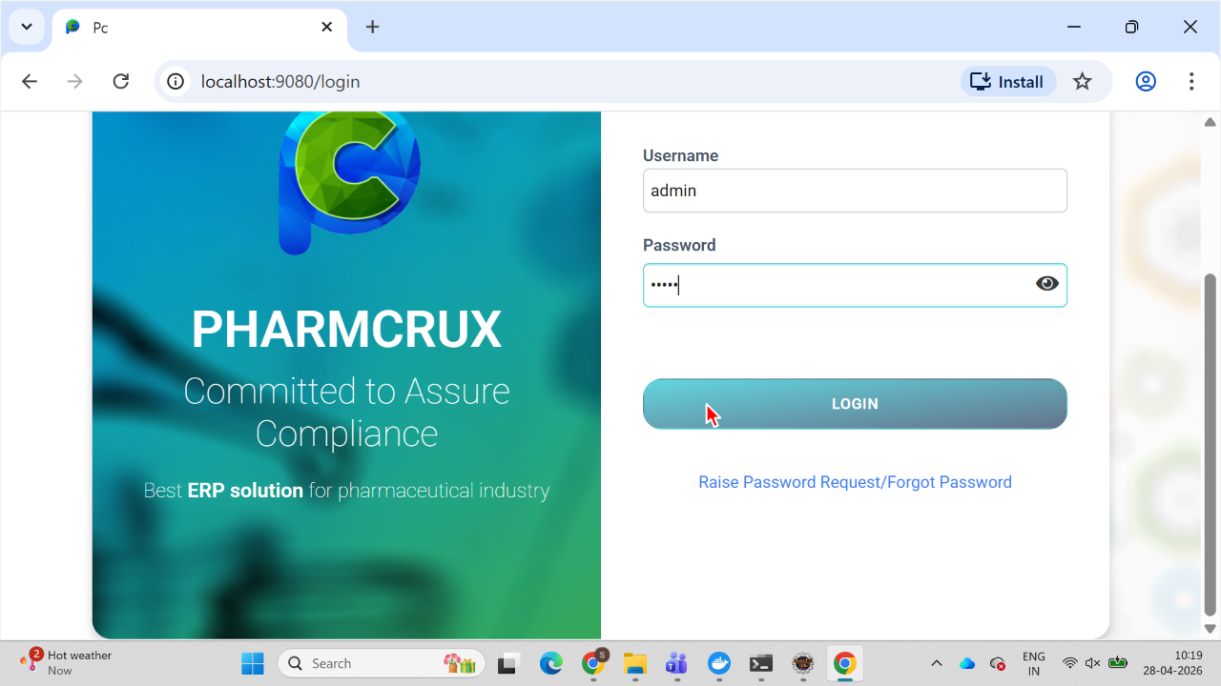
Screenshot - 02 for Step No:4.4.1
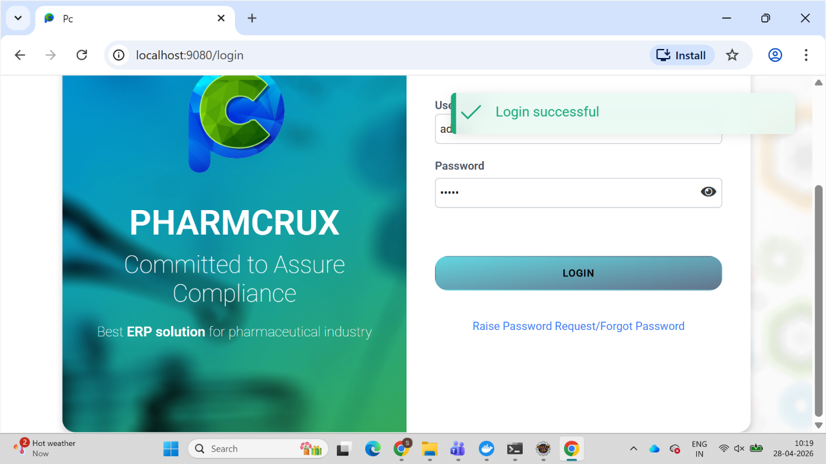
Screenshot - 03 for Step No:4.4.1
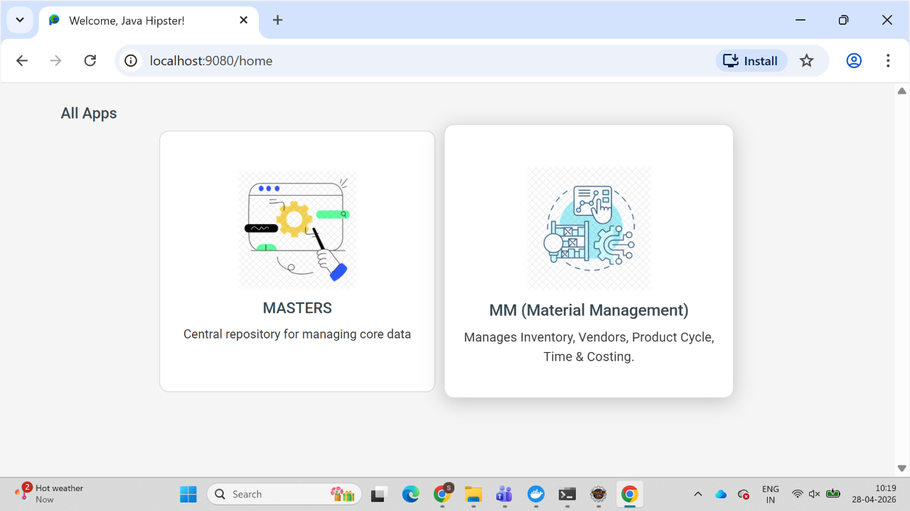
Screenshot - 04 for Step No:4.4.1
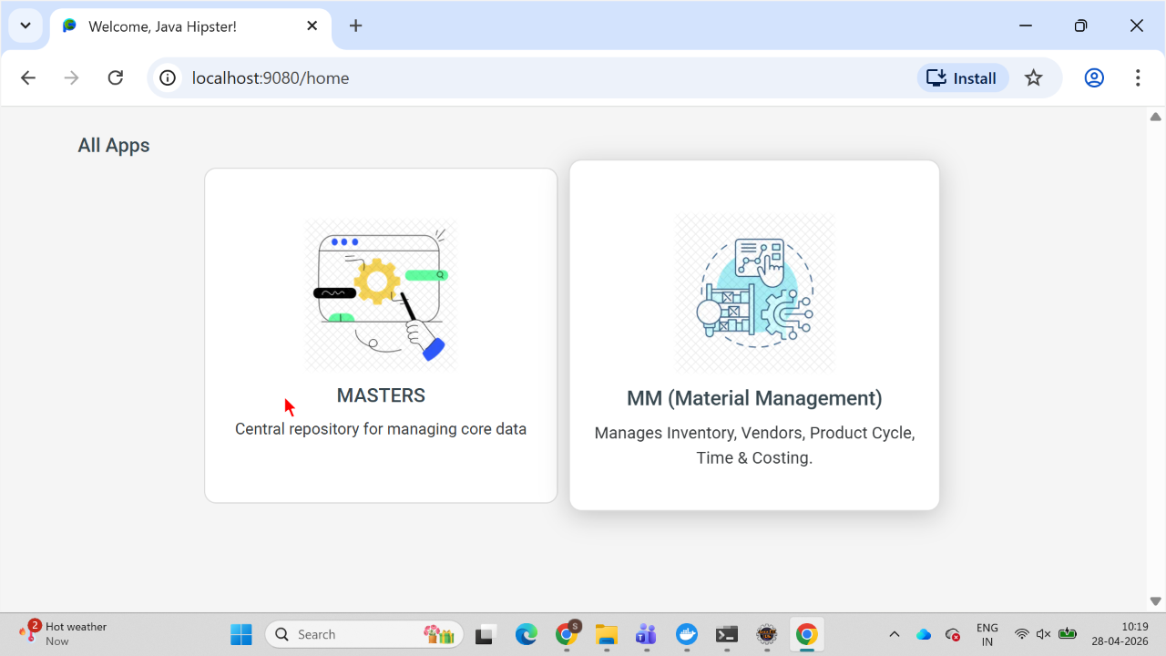
Screenshot - 05 for Step No:4.4.1
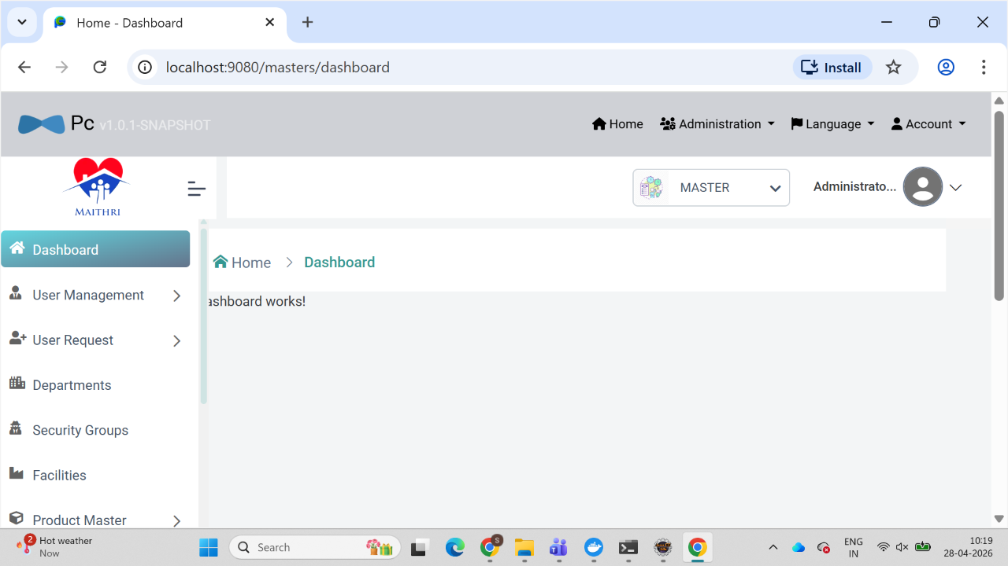
Screenshot - 06 for Step No:4.4.1
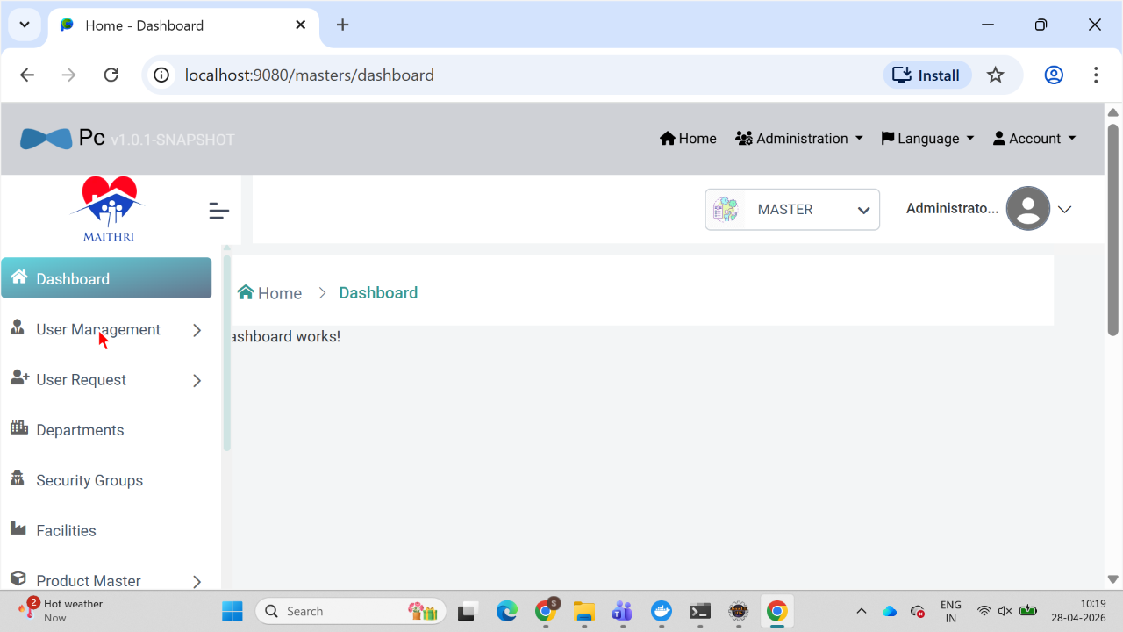
Screenshot - 07 for Step No:4.4.1
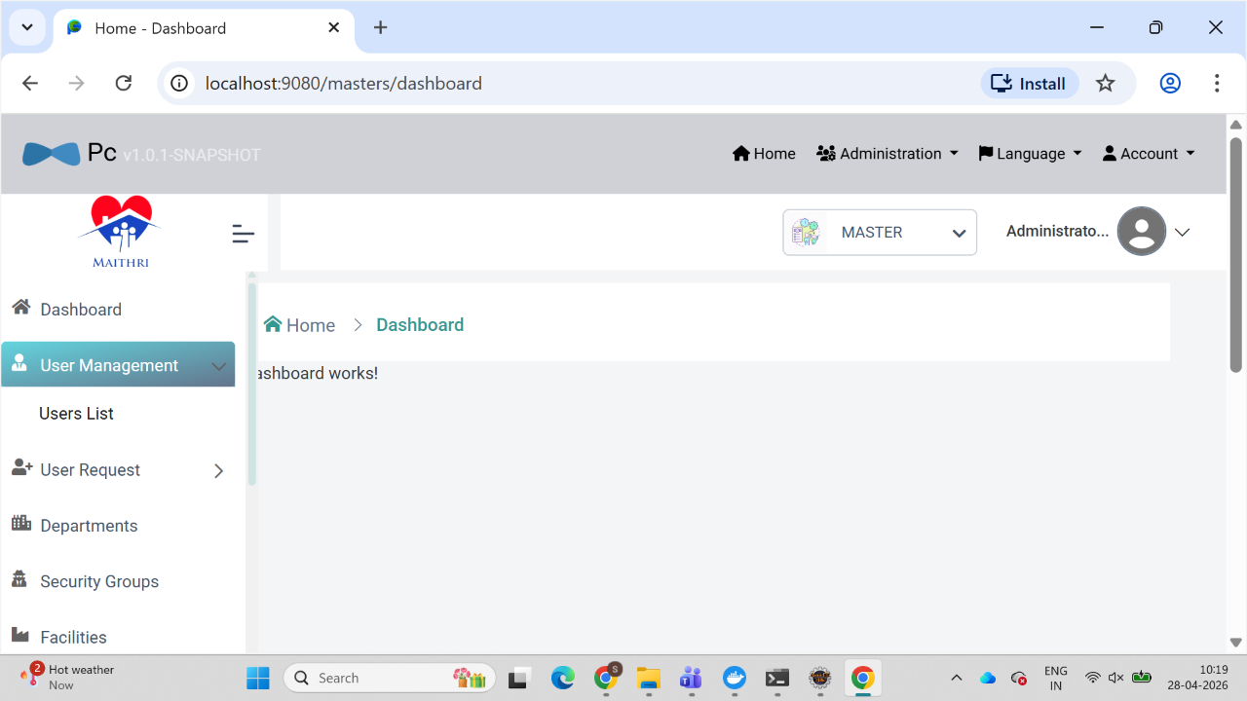
Screenshot - 08 for Step No:4.4.1
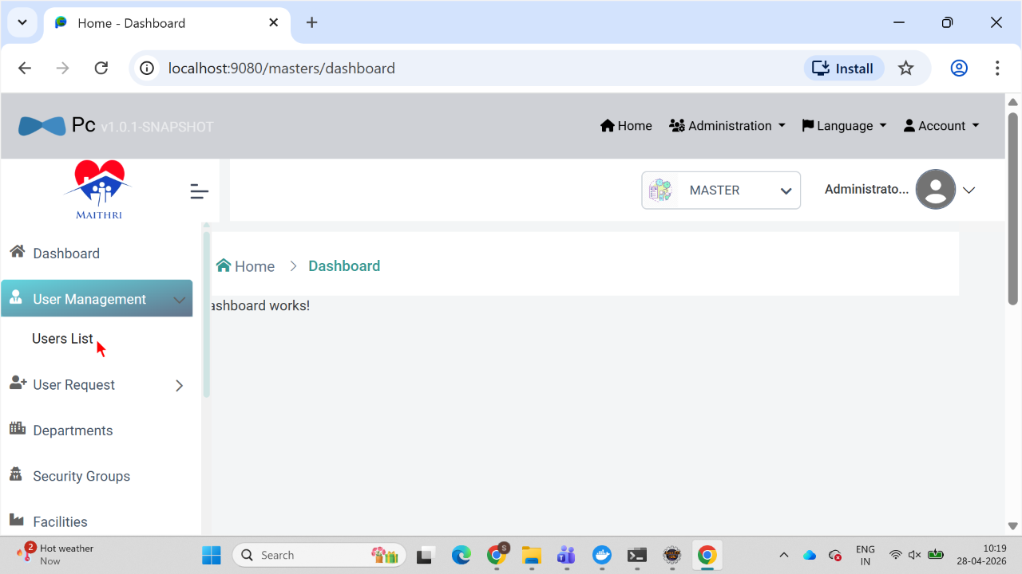
Screenshot - 09 for Step No:4.4.1
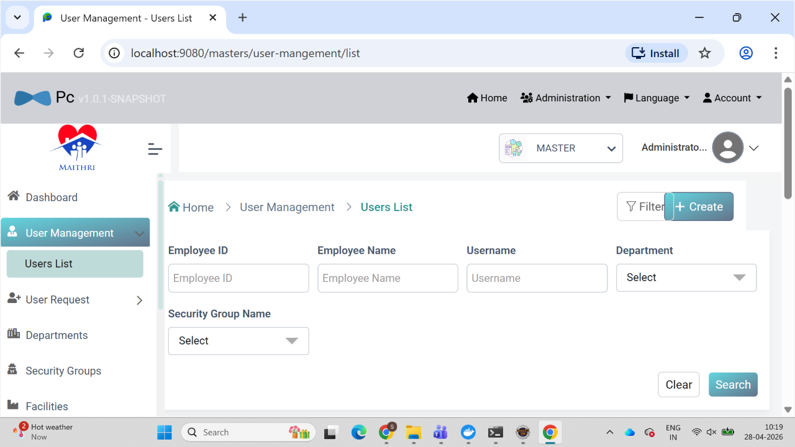
Screenshot - 01 for Step No:4.4.2
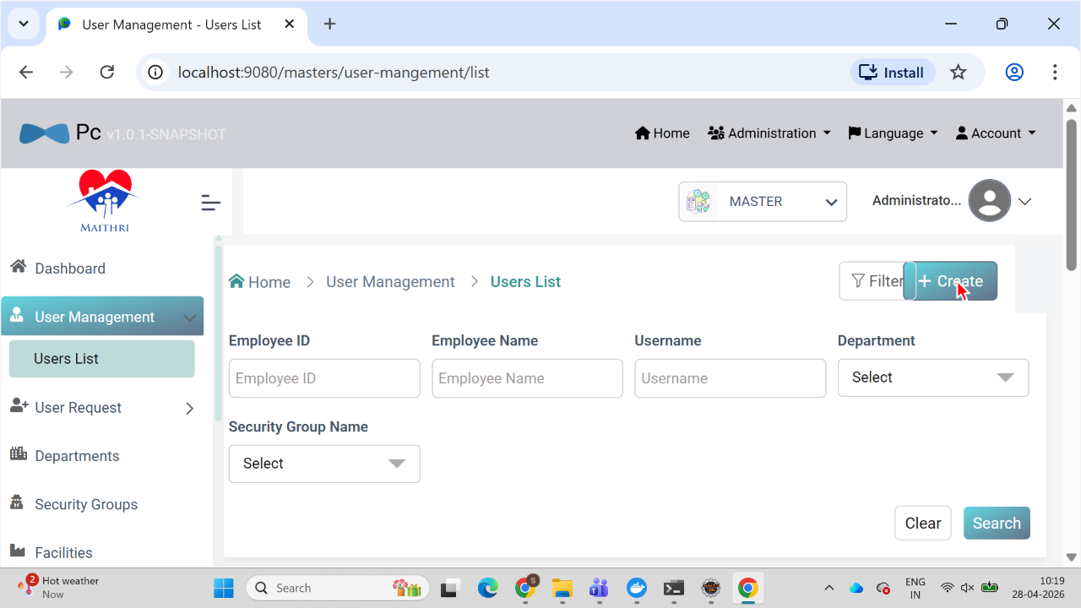
Screenshot - 02 for Step No:4.4.2
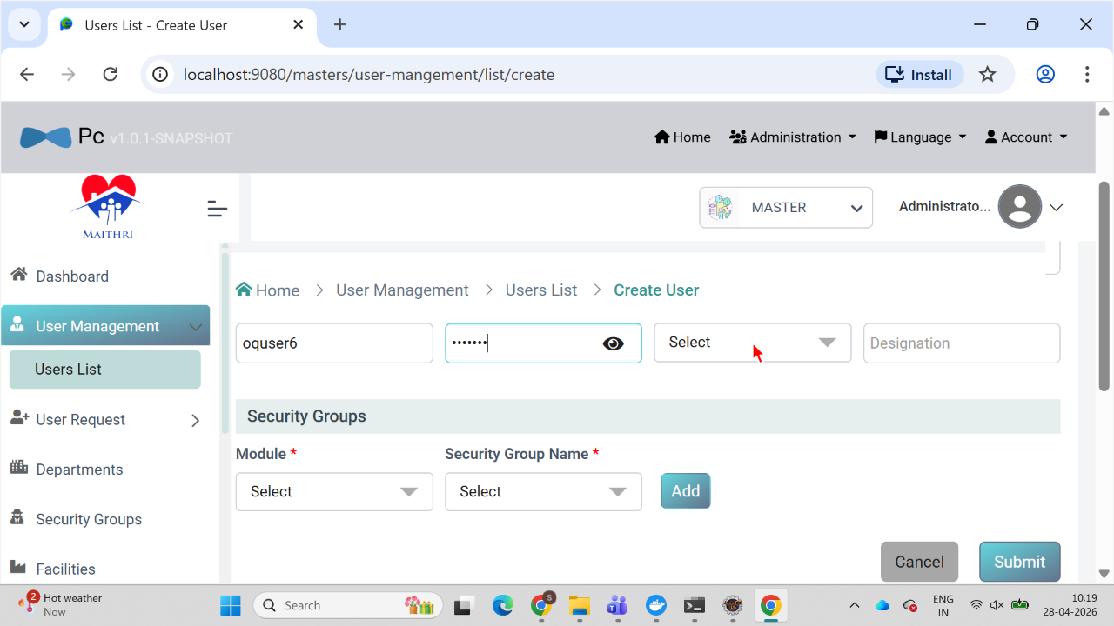
Screenshot - 03 for Step No:4.4.2
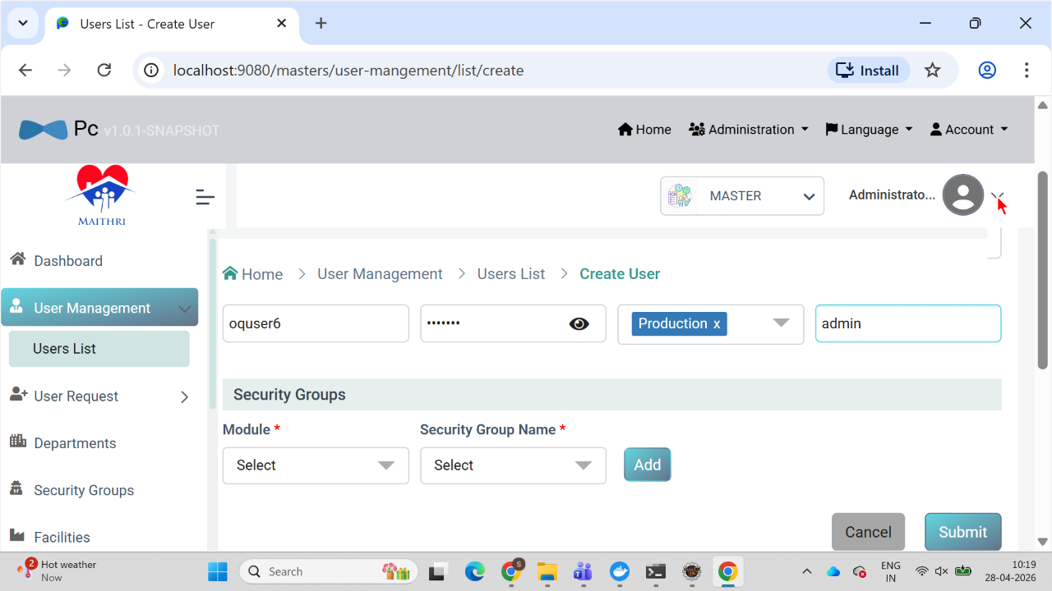
Screenshot - 04 for Step No:4.4.2
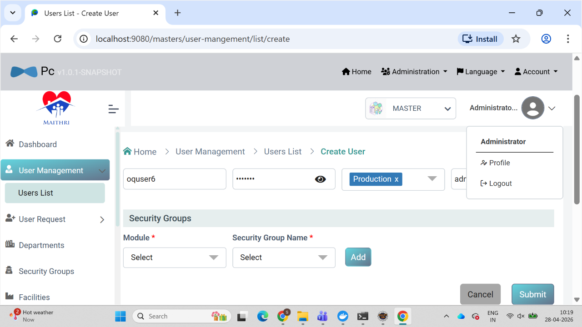
Screenshot - 05 for Step No:4.4.2
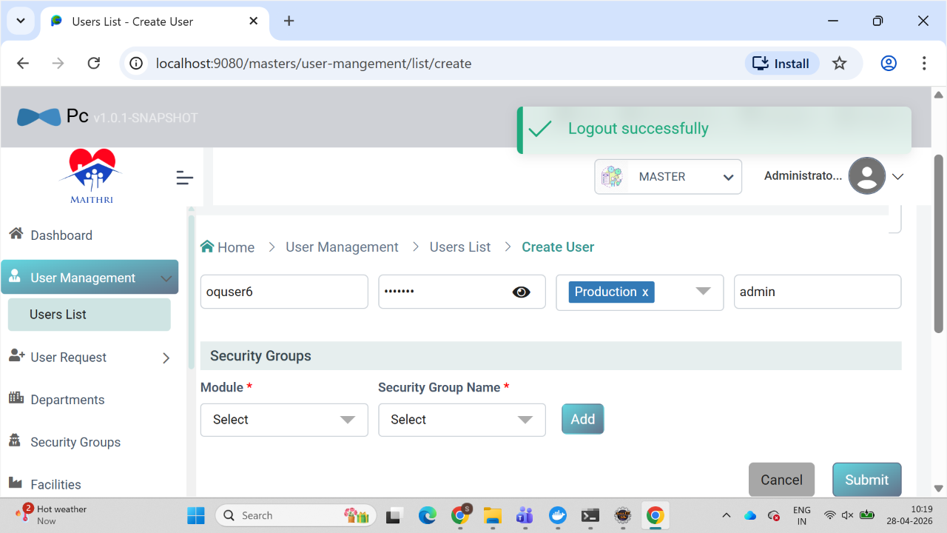
Screenshot - 06 for Step No:4.4.2
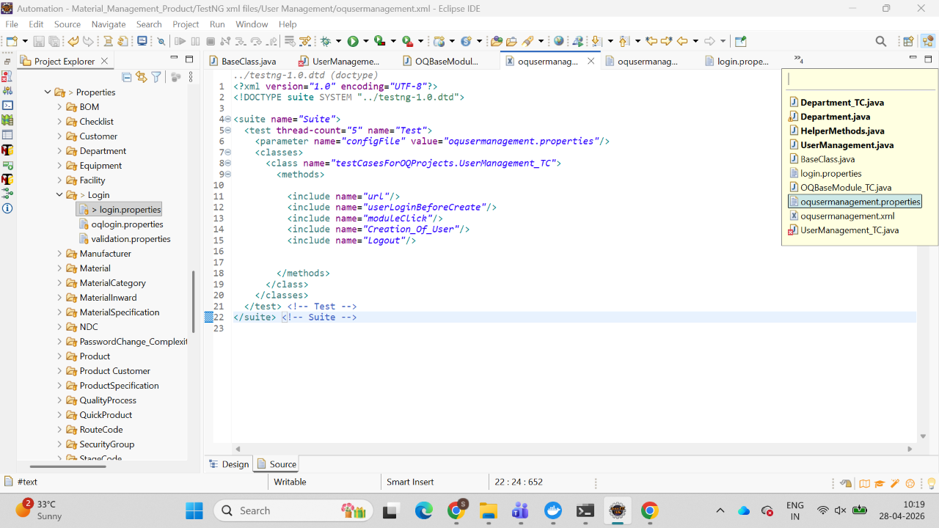

Test Duration Details: | Start Date : |  | End Date:
 | Total Screenshots : |  | No. of Testers:
Remarks:

Executed by
Executed by | Name | Title, Department | Signature | Date

Reviewed By
Reviewed By | Name | Title, Department | Signature | Date

Reviewed By
Reviewed By | Name | Title, Department | Signature | Date

Approved By
Approved By | Name | Title, Department | Signature | Date

